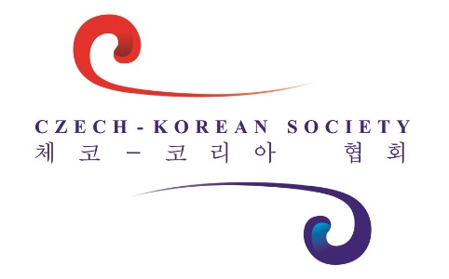

Business Development Assistant
Fall 2016 Trainee Program
The Czech-Korean Society, an NGO operating in the Czech Republic and Korea, is recruiting for two Business Development Assistants to join our team based in Prague and Seoul to work on projects in developing business relations between Czech Republic and Korea. The position is opened as a part-time (15hours/week, flexible) 4-month trainee program beginning in October 2016, with the possibility of a long-term full-time employment.
The role would suit a graduate/graduate student of marketing, business management, international business or IR, interested in getting a chance to apply their knowledge on real-life projects under the umbrella of successful international NGO.
To apply, you should have:
- Business research and analytical skills,
- A "can do" attitude and high level of stress-resistance,
- Strong project management skills,
- Passion for the East Asian region,
- Excellent command of English (knowledge of Korean, Chinese or Japanese is a plus),
- Good knowledge of MS Word, Excel, PowerPoint and social media.
To successful candidates, we offer:
- Trainee program guided by experienced professionals,
- Negotiable financial support to cover personal costs,
- Excellent networking opportunity in East Asian business relations,
- Chance to be fully in charge of selected projects (incl. leadership opportunities),
- Possibility of a long-term job placement.
If interested, please send your CV and cover letter in English to hr@cks-korea.cz by September 30, 2016. More info at www.cks-korea.cz.

